# A Project Report ON

**“EMOTIONAL AND MENTAL ANALYST - EMA”**

Submitted to the

Savitribai Phule Pune University

In partial fulfillment for the award of Degree of

Bachelor of Engineering

In

Information Technology

By

**Mr. Durgesh Patil PRN No: 71931898L**

**Mr. Utkarsh Bhangale PRN No: 71931878F**

**Ms. Sujata Junare PRN No: 71931890E**

**Ms. Dhanashree Kulkarni PRN No: 71931892M**

Under the Guidance of

# Prof. Nitin Dhawas



Department of Information Technology

**PCET’S**

**Nutan Maharashtra Institute of Engineering and Technology,**

# Talegaon Dabhade, Pune 2019-20



**Savitribai Phule Pune University**

# Nutan Maharashtra Institute of Engineering and Technology

## TALEGAON DABHADE, PUNE-415 507



DEPARTMENT OF INFORMATION TECHNOLOGY

**CERTIFICATE**

This is to certify that the Project Entitled

**“EMOTIONAL AND MENTAL ANALYST - EMA**”

Submitted by

**DURGESH PATIL Roll No: BI45**

**UTKARSH BHANGALE Roll No: BI03**

**SUJATA JUNARE Roll No: BI28**

**DHANASHREE KULKARNI Roll No: BI34**

Is a bonafide work carried out by Students under the supervision of **Prof. Nitin Dhawas** and it is submitted towards the partial fulfillment of the requirement of Bachelor of Engineering (Information Technology).

Date: 08-06-2021

Place: Talegaon

|  |  |
| --- | --- |
| **Prof.Nitin Dhawas** | **Prof. Aditi Das** |
| Seminar Guide | Project Coordinator |
| **Prof.Nitin Dhawas** | **Dr. Lalitkumar Wadhwa** |
| Head of Department | Principal |

Signature of External Examiner

## ACKNOWLEDGMENT

We have great pleasure and sense of satisfaction in presenting the report on

”EMOTIONAL AND MENTAL ANALYST - EMA” as part of curriculum of Bachelor of Engineering. Being novice in the field of designing and structuring in the report, it could have been extremely difficult for us to complete this report on our work. We are very fortunate to be guided by people with vast and resourceful experience in their respective field of work.

We express our sincere gratitude to our guide Prof.Nitin Dhawas and project coordinator Prof. Aditi Das for their timely guidance, support and suggestions. Besides, we take this opportunity to express our sincere gratitude to the

Principal Dr.Lalitkumar Wadhwa, PCET’s NMIET for providing a good environment and facilities to complete this project. We would also like to thank all our colleagues who have correctly or indirectly guided and helped us in the preparation of this report and also giving us an unending support right from the stage this idea was conceived. We also acknowledge the research work done by all worldwide researchers in this field.

**Mr. Durgesh Patil**

**Mr. Utkarsh Bhangale**

**Ms. Sujata Junare**

**Ms. Dhanashree Kulkarni**

# ABSTRACT

Whether chatbots, robots, and other vessels for artificial intelligence *should* become placeholders for emotional relationships with real humans is up for debate. The rise of emotional machines calls to mind science fiction films like *Ex Machina* and *Her*, and raises questions about the ever more intimate relationships between humans and computers. But already, some AI researchers and roboticists are developing products for exactly this purpose, testing the limits of how much machines can learn to mimic and respond to human emotion.

Humans share a universal and fundamental set of emotions, which are exhibited through consistent facial expressions, talking and writing/texting. An algorithm that performs detection, extraction, and evaluation of these expressions will allow for automatic recognition of human emotion in images, voice and text. Presented here is a hybrid feature extraction and facial expression recognition method that utilizes Viola-Jones cascade object detectors using Haar cascades extract faces and facial features, pyttsx3 which is a text-to-speech conversion library in Python and text2emotion support vector machine to determine emotion from text

The chatbot, which bills itself as "your charming robot friend who is ready to listen, 24/7,” uses artificial intelligence to offer emotional support and talk therapy, like a friend or a therapist. The bot checks in on users once a day, asking questions like “How are you feeling?” and “What is your energy like today?” The chatbot creates a space for mental health tools to become more accessible and available—plus, humans open up more when they know they're talking to a bot. "We know that often, the greatest reason why somebody doesn’t talk to another person is just stigma," she says. "When you remove the human, you remove the stigma entirely."

**Key Words:** **Chatbot,** **Emotions, Python, Facial recognition.**

|  |  |  |  |  |  |  |  |
| --- | --- | --- | --- | --- | --- | --- | --- |
|  | | | | | | | |
|  | Chapter | | **CONTENTS** | | Page No. | |  |
|  | | **Title** | |  | |
|  | | **Certificate** | |  | |
|  | | **Acknowledgement** | |  | |
|  | | **Abstract** | |  | |
| **1** | | **Introduction** | | 7 | |
|  | | 1.1 Domain: Artificial intelligence/machine learning | | 8 | |
|  | | 1.2 AI/ML in emotional and mental analyst | |  | |
|  | | 1.3Motivation | |  | |
| **2** | | **Literature Survey** | | 9 | |
| **3** | | **Software Requirement Specification** | |  | |
|  | | 3.1 Functional Requirements | |  | |
|  | | 3.2 Non- Functional Requirements | |  | |
|  | | 3.3 Software Quality Attributes | |  | |
|  | | 3.4 System Requirements | | 12 | |
|  | | 3.4.1 Software Requirements | |  | |
|  | | 3.4.2 Hardware Requirements | |  | |
| **4** | | **Existing System** | | 14 | |
| **5** | | **Proposed System** | | 15 | |
|  | | 5.1 System Components | |  | |
|  | | 5.1.1 Python | |  | |
|  | | 5.1.2 OpenCV | |  | |
|  | | 5.1.3 Viola Jones | |  | |
|  | | 5.1.4 Haar Cascade | |  | |
|  | | 5.1.5 Pyttx3 | |  | |
|  | | 5.1.6 Text2Emotion | |  | |
|  | | 5.1.7 CNN | |  | |
| **6** | | **System Design** | | 18 | |
|  | | 6.1 System Diagram | |  | |
|  | | 6.2 Flowchart | |  | |
|  | | 6.3 Block Diagram | |  | |
|  | | 6.4 Training Diagram | |  | |
|  | | 6.5 Use case Diagram | |  | |
|  | | 6.6 Activity Diagram | |  | |
| **7** | | **Software Testing** | | 22 | |
| **8** | | **Applications And Advantages** | | 24 | |
|  | | 8.1 Applications | |  | |
|  | | 8.2 Advantages | |  | |
| **9** | | **Challenges And Future Work** | | 25 | |
| **10** | | | **Conclusion** | | 26 | |
| **11** | | | **References** | | 27 | |

**CHAPTER 1**

## INTRODUCTION

Värnik claims India's adjusted annual suicide rate is 10.5 per 100,000, while the suicide rate for the world as a whole is 11.6 per 100,000.Every hour, one student commits suicide in India. This present catastrophe of the pandemic has struck us with many disturbing events. Every soul on earth is terrified to go out in the vicinity. There is no other option but to clutch ourselves in the house and deal with the situation as deliberately as possible. In such situations, our mental health has been greatly neglected and has resulted in depression and psychological disorders. To relieve such distressed mindsets, one need to share his thoughts instead of clamming it inside. But in such introvert situations, one is hesitant and reserved to open up to somebody resulting in shyness and humiliation. To overcome this dilemma, we are introducing a human like A.I. chatbot which recognises the emotions of the user by interacting with simple conversation and analyse what abrupt thoughts might lay in the user's mind. The user may name the bot anything he likes and shares his emotions, his thoughts, his psychological dilemmas with it and seek for solution. The bot will analyse what the user is dealing with and provide the user with comforting words, fun games, jokes, mind-soothing exercises, daily diary logs, daily mood tracker and much more stuff that will ease the user's nerves. This will allow users to share their thoughts and worries without hesitation and shyness. The user's data will be secure enough and can be manipulated by the user as per his liking. Interpersonal interaction is often times intricate and nuanced, and its success is often predicated upon a variety of factors. These factors range widely and can include the context, mood, and timing of the interaction, as well as the expectations of the participants. For one to be a successful participant, one must perceive a counterpart’s disposition as the interaction progresses and adjust accordingly. Fortunately for humans this ability is largely innate, with varying levels of proficiency. Humans can quickly and even subconsciously assess a multitude of indicators such as word choices, voice inflections, and body language to discern the sentiments of others. This analytical ability likely stems from the fact that humans share a universal set of fundamental emotions. Significantly, these emotions are exhibited through facial expressions that are consistently correspondent. This means that regardless of language and cultural barriers, there will always be a set of fundamental facial expressions that people assess and communicate with. After extensive research, it is now generally agreed that humans share seven facial expressions that reflect the experiencing of fundamental emotions. These fundamental emotions are anger, contempt, disgust, fear, happiness, sadness, and surprise. Unless a person actively suppresses their expressions, examining a person’s face can be one method of effectively discerning their genuine mood and reactions. The universality of these expressions means that facial emotion recognition is a task that can also be accomplished by computers. Furthermore, like many other important tasks, computers can provide advantages over humans in analysis and problem-solving. Computers that can recognize facial expressions can find application where efficiency and automation can be useful, including in entertainment, social media, content analysis, criminal justice, and healthcare. For example, content providers can determine the reactions of a consumer and adjust their future offerings accordingly

**1.1 DOMAIN: ARTIFICIAL INTELLIGENCE/MACHINE LEARNING**

Artificial intelligence is a field of computer science, which makes a computer system that can mimic human intelligence. It is comprised of two words "**Artificial**" and "**intelligence**", which means "a human-made thinking power." Hence, we can define it as,

*Artificial intelligence is a technology using which we can create intelligent systems that can simulate human intelligence.*

The Artificial intelligence system does not require to be pre-programmed, instead of that, they use such algorithms which can work with their own intelligence. It involves machine-learning algorithms such as Reinforcement learning algorithm and deep learning neural networks. AI is being used in multiple places such as Siri, Google’s AlphaGo, AI in Chess playing, etc.

Machine learning is about extracting knowledge from the data. It can be defined as,

*Machine learning is a subfield of artificial intelligence, which enables machines to learn from past data or experiences without being explicitly programmed.*

Machine learning enables a computer system to make predictions or take some decisions using historical data without being explicitly programmed. Machine learning uses a massive amount of structured and semi-structured data so that a machine learning model can generate accurate result or give predictions based on that data.

**1.2 AI/ML IN EMOTIONAL AND MENTAL ANALYST**

You can use AI/ML algorithms to train the system as per our requirements:

* + Detecting emotions
  + Extracting features from scanning objects
  + Performing user programmed functions

**1.3 MOTIVATION**

* To understand the users’ complex and conflicting thoughts.
* To analyze the users’ state of mind.
* To provide a confidential trustworthy medium for the users to organize their thoughts with life-like interaction.
* To provide remedial exercises and routines to eliminate disputing thoughts form users mind and avoiding any self-harm causing intentions of the user

**CHAPTER 2**

## LITERATURE SURVEY

1. **Title of Paper: Combating Depression in Students using an Intelligent ChatBot: A Cognitive Behavioral Therapy**

Author: Falguni Patel, Riya Thakore, Ishita Nandwani, Santosh Kumar Bharti

Description: Chatbots are special agents that respond with the user in natural language just as a human would reply. Specifically, social chatbots are the ones which establish a strong emotional relationship with the user. The main concept behind this chatbot was to provide mental relief to students who undergo different levels of stress and which can be the onset of an inimical depression. In this paper, we proposed an intelligent social therapeutic chatbot which distributes the text into emotion labels namely, Happy, Joy, Shame, Anger, Disgust, Sadness, Guilt, and Fear. Further, based on the emotion label, it identify the users' mental state such as stressed or depressed using users' chat data. For emotion detection, we deployed three popular deep learning classifiers namely, Convolutional Neural Network (CNN), Recurrent Neural Network (CNN), and Hierarchical Attention Network (HAN). In particular, the proposed methodology of the chatbot is domain specific where through the users' interaction, the chatbot will try to prevent the pessimistic actions and rebuild more constructive thoughts.

Year: 2019

Publication: IEEE

1. **Title of Paper:** **Model of Multi-turn Dialogue in Emotional Chatbot**

Author[:](https://ieeexplore.ieee.org/author/37086349426) Chien-Hao Kao, Chih-Chieh Chen, Yu-Tza Tsai

Description: The intent recognition and natural language understanding of multi-turn dialogue is key for the commercialization of chatbots. Chatbots are mainly used for the processing of specific tasks, and can introduce products to customers or solve related problems, thus saving human resources. Text sentiment recognition enables a chatbot to know the user's emotional state and select the best response, which is important in medical care. In this study, we combined the multi-turn dialogue model and sentiment recognition model to develop a chatbot, that is designed for used in daily conversations rather than for specific tasks. Thus, the chatbot has the ability to provide the robot's emotions as feedback while talking with a user. Moreover, it can exhibit different emotional reactions based on the content of the user's conversation.

Year: 2019

Publication: IEEE

1. **Title of Paper**: **Deep learning based Text Emotion Recognition for Chatbot applications.**

Author: Mounika Karnaa , Sujitha Juliet D.b , R.Catherine Joyc

Description: Emotions play a vital role in human interaction. We recognize emotion of a person from their speech, face gesture, body language and sign actions. Since humans use many text devices to make interactions these days, emotion extraction from the text has drawn a lot of importance. It is therefore crucial that emotions in textual conversation need to be well understood by the machines, which ultimately provide users with emotional awareness feedback. This paper investigates the effectiveness of deep learning based Long Short-Term Memory mechanism for identification of textual emotions. The study was carried out on `Emotion classification' dataset with six emotional groups. The experimental results proved that LSTM based text emotion classification provides relatively higher accuracy compared to the existing learning methods.

Year: 2020

Publication: IEEE

**CHAPTER 3**

## SOFTWARE REQUIREMENT SPECIFICATION (SRS)

**FUNCTIONAL REQUIREMENTS**

It deals with the functionalities required from the system which are as follows:

* To understand the users’ complex and conflicting thoughts.
* To analyze the users’ state of mind.
* To provide a confidential trustworthy medium for the users to organize their thoughts with life-like interaction.
* To provide remedial exercises and routines to eliminate disputing thoughts form users mind and avoiding any self-harm causing intentions of the user

**NON-FUNCTIONAL REQUIREMENTS**

They specify certain criteria that can be used to judge the operation of a system:

1. **PERFORMANCE:** 
   1. Performance of the functions and every module must be well. The overall performance of the software will enable the users to work efficiently.
   2. System should process requested task in parallel for various action to give quick response. Then system must wait for process completion.
   3. System should correctly execute process, display the result accurately. System output should be in user required format.
2. **SAFETY:** 
   1. The application is designed in modules where errors can be detected and fixed easily. This makes it easier to install and update new functionality if required.
   2. The data safety must be ensured by arranging for a secure and reliable transmission media. The source and destination information must be entered correctly to avoid any misuse or malfunctioning.
   3. Password generated by user is consisting of characters, special character and number so that password is difficult to hack. So, that user account is safe.

1. **SECURITY:** 
   1. User information can only view by user himself/herself. Secure access of confidential data

(user details).

* 1. Information security means protecting information and information systems from unauthorized access, use, disclosure, disruption, modification or destruction.
  2. User password must be stored in encrypted form for the security reason.
  3. All the user details shall be accessible to only high authority persons.
  4. Access will be controlled with usernames and passwords.

1. **USABILITY:**

The system should be user friendly and should require least effort to operate.

1. **RELIABILITY:**

The system should be extremely reliable and secure, as the particular user data should not get leaked anywhere.

**SOFTWARE QUALITY ATTRIBUTES**

Our software has many quality attribute that are given below:- *•* Adaptability: This software is adaptable by all users.

* + Availability: This software is freely available to all users. The availability of the software is easy for everyone.
  + Maintainability: After the deployment of the project if any error occurs then it can be easily maintained by the software developer.
  + Reliability: The performance of the software is better which will increase the reliability of the Software.
  + User Friendliness: Since, the software is a GUI application; the output generated is much user friendly in its behavior.
  + Integrity: Integrity refers to the extent to which access to software or data by unauthorized persons can be controlled.
  + Security: Users are authenticated using many security phases so reliable security is pro- vided.
  + Testability: The software will be tested considering all the aspects.

**SYSTEM REQUIREMENTS**

**SOFTWARE REQUIREMENTS**

* + Operating System : Windows
  + Front End : Python
  + IDE : Jupyter Notebook
  + Database : MySQL, MS Excel

**HARDWARE REQUIREMENTS**

* + Webcam
  + Speaker
  + Microphone

**CHAPTER 4**

## EXISTING SYSTEM

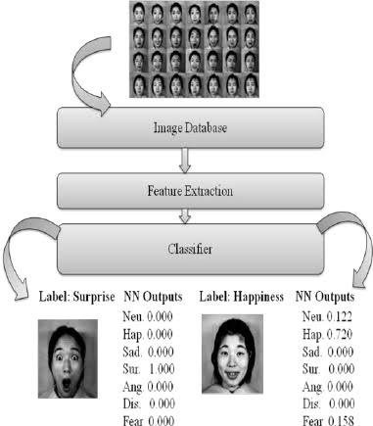

**Fig: Existing System Block Diagram**

In this, we present the theory on real time monitoring of face and its different emotions. In this existing block diagram consist of an image database which is used to compare with the scanned face of the user and classifying the emotions using the captured features.

As this topic is of interest in many fields spanning both social sciences and engineering, there have been many approaches in using computers to detect, extract, and recognize human facial features and expressions as well as emotions from face, speech and text. For example, these techniques are commonly used in AI assistants like Google assistant, Microsoft Cortana, Apple Siri, Samsung Bixby, etc. The recent android application Replika: My AI friend uses these features impressively.

**CHAPTER 5**

## PROPOSED SYSTEM

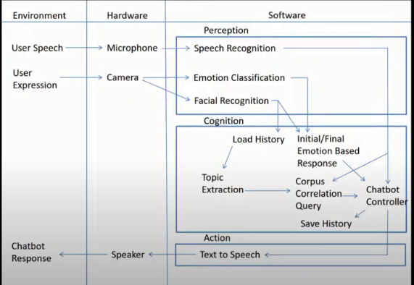

**Fig: Proposed System Diagram.**

**SYSTEM COMPONENTS**

**PYTHON**

Python is a high-level, interpreted, interactive and object-oriented scripting language. Python is designed to be highly readable. It uses English keywords frequently whereas the other languages use punctuations. It has fewer syntactical constructions than other languages.

* **Python is Interpreted** − Python is processed at runtime by the interpreter. You do not need to compile your program before executing it. This is similar to PERL and PHP.
* **Python is Interactive** − You can actually sit at a Python prompt and interact with the interpreter directly to write your programs.
* **Python is Object-Oriented** − Python supports Object-Oriented style or technique of programming that encapsulates code within objects.
* **Python is a Beginner's Language** − Python is a great language for the beginner-level programmers and supports the development of a wide range of applications from simple text processing to WWW browsers to games.

**OpenCV**

OpenCV is a cross-platform library using which we can develop real-time **computer vision applications**. It mainly focuses on image processing, video capture and analysis including features like face detection and object detection.

Let’s start the chapter by defining the term "Computer Vision".

**Viola Jones Cascade**

Viola Jones algorithm is named after two computer vision researchers who proposed the method in 2001, Paul Viola and Michael Jones in their paper, “Rapid Object Detection using a Boosted Cascade of Simple Features”. Despite being an outdated framework, Viola-Jones is quite powerful, and its application has proven to be exceptionally notable in real-time face detection. This algorithm is painfully slow to train but can detect faces in real-time with impressive speed.

**Haar Cascade**

Haar-like features are digital image features used in object recognition. All human faces share some universal properties of the human face like the eyes region is darker than its neighbour pixels, and the nose region is brighter than the eye region.

A simple way to find out which region is lighter or darker is to sum up the pixel values of both regions and compare them. The sum of pixel values in the darker region will be smaller than the sum of pixels in the lighter region. If one side is lighter than the other, it may be an edge of an eyebrow or sometimes the middle portion may be shinier than the surrounding boxes, which can be interpreted as a nose This can be accomplished using Haar-like features and with the help of them, we can interpret the different parts of a face.

**Pyttsx3:**

pyttsx3 is a text-to-speech conversion library in Python. Unlike alternative libraries, it works offline and is compatible with both Python 2 and 3..

**Text2emotion**

**text2emotion is the python package which will help you to extract the emotions from the content.**

* Processes any textual message and recognize the emotions embedded in it.
* Compatible with 5 different emotion categories as Happy, Angry, Sad, Surprise and Fear.

**CNN:**

A **Convolutional Neural Network (ConvNet/CNN)** is a Deep Learning algorithm which can take in an input image, assign importance (learnable weights and biases) to various aspects/objects in the image and be able to differentiate one from the other. The pre-processing required in a ConvNet is much lower as compared to other classification algorithms. While in primitive methods filters are hand-engineered, with enough training, ConvNets have the ability to learn these filters/characteristics.

**CHAPTER 6**

## SYSTEM DESIGN

The detection and recognition implementation proposed here is a supervised learning model that will use the one versus-all (OVA) approach to train and predict the seven basic emotions (anger, contempt, disgust, fear, happiness, sadness, and surprise).

The overall face extraction from the image is done first using a Viola-Jones cascade object face detector. The ViolaJones detection framework seeks to identify faces or features of a face (or other objects) by using simple features known as Haar-like features. The process entails passing feature boxes over an image and computing the difference of summed pixel values between adjacent regions. The difference is then compared with a threshold which indicates whether an object is considered to be detected or not. This requires thresholds that have been trained in advance for different feature boxes and features. Specific feature boxes for facial features are used, with expectation that most faces and the features within it will meet general conditions. Essentially, in a feature-region of interest on the face it will generally hold that some areas will be lighter or darker than surrounding area.



**Fig: System Design**

**6.1] FLOWCHART:**

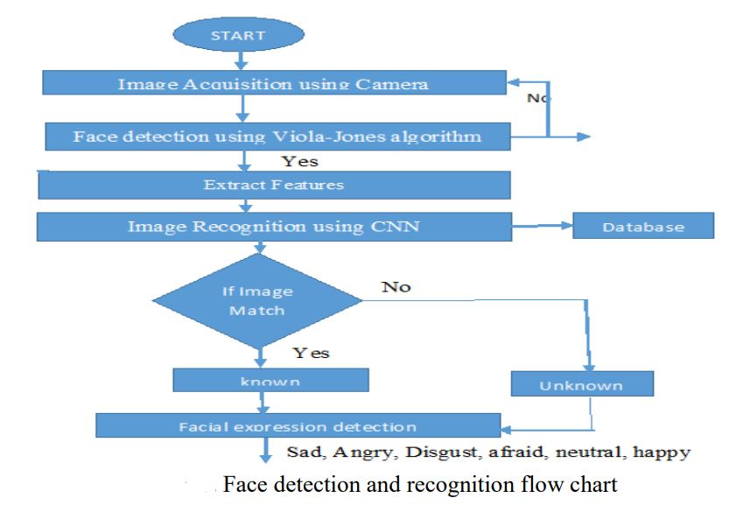

**Fig: Flow Chart**

**6.2] BLOCK DIAGRAMM:**

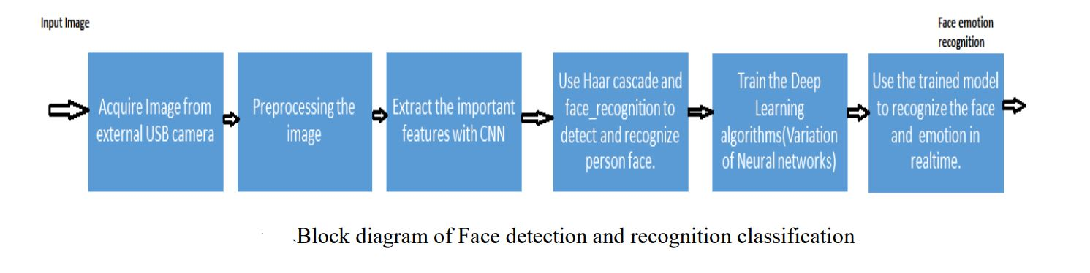

**6.3 TRAINING DIAGRAM:**

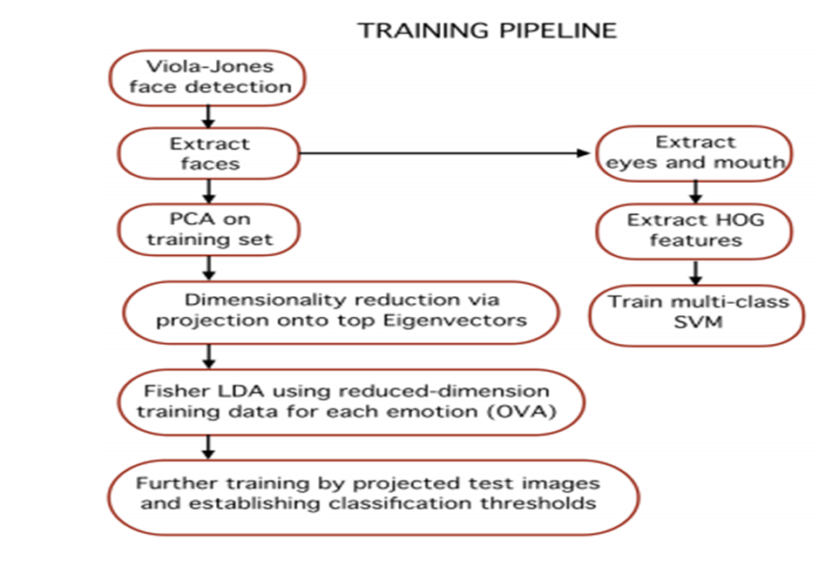

**6.4] USECASE DIAGRAM:**

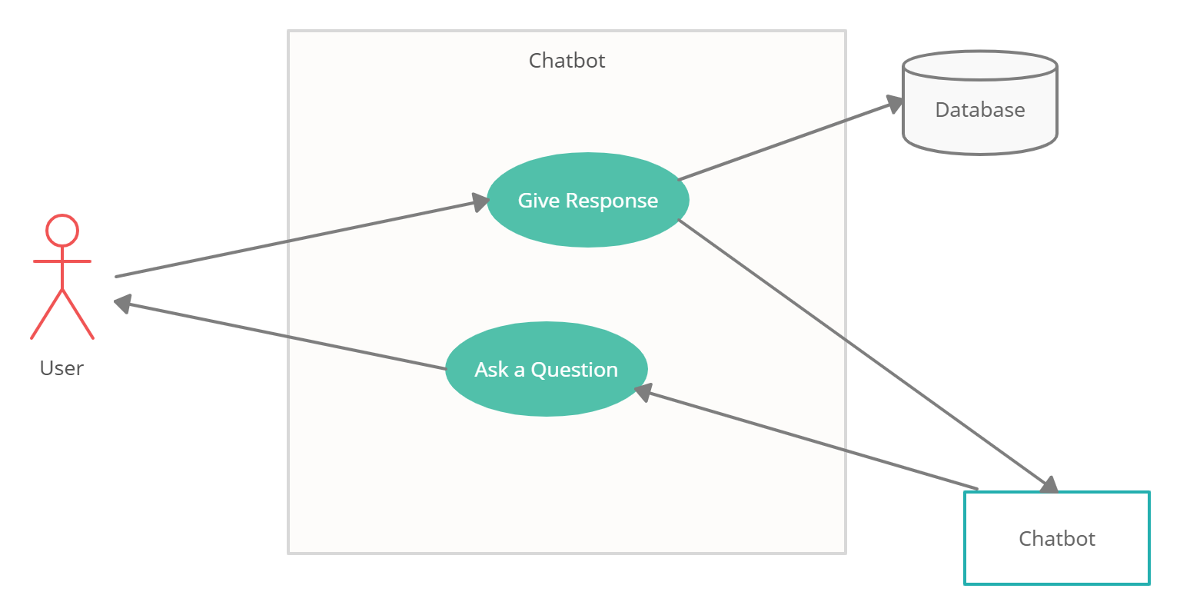

**6.5] ACTIVITY DIAGRAM:**

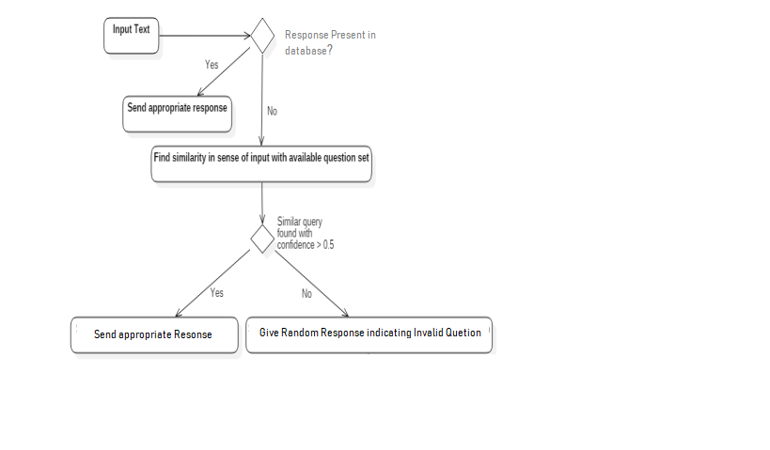

**CHAPTER 7**

## SOFTWARE TESTING

Software Testing is the process of executing a program or system with the intent of finding errors or it involves any activity aimed at evaluating an attribute or capability of a program or system and determining that it meets its required results.

**TEST CASES AND TEST RESULT:**

|  |  |
| --- | --- |
| **Test Case ID** | **1** |
| **Test Case Description** | **Capturing face emotion** |
| **Steps** | **Open the chatbot and start camera** |
| **Test Case Result** | **Detecting the face emotion** |
| **Action Result** | **Showing emotion sad,happy,etc** |
| **Status** | **Pass** |

|  |  |
| --- | --- |
| **Test Case ID** | **2** |
| **Test Case Description** | **Asking questions to the user** |
| **Steps** | **Ask random question to the to the user** |
| **Test Case Result** | **Chatbot asks the question** |
| **Action Result** | **Recorded Successfully** |
| **Status** | **Pass** |

|  |  |  |
| --- | --- | --- |
| **Test Case ID** | **3** | |
| **Test Case Description** | **Getting answer from the user** | |
| **Steps** | **User gives the answer** | |
| **Test Case Result** | **Chatbot records the answer.** | |
| **Action Result** | **Pass** | |
| **Status** | **Pass** | |
| **Test Case ID** | | **4** |
| **Test Case Description** | | **Generate report at the end of the conversation** |
| **Steps** | | **Chatbot records questions and answers and makes a report** |
| **Test Case Result** | | **Report generated successfully** |
| **Action Result** | | **Report Generation successful** |
| **Status** | | **Pass** |

## CHAPTER 8

**APPLICATIONS AND ADVANTAGES**

**APPLICATIONS:**

1. This system is used in commercial and domestic use.

1. Mainly helpful for Water Supply Agencies

3.For health department to identify the reason of water diseases.

**ADVANTAGES:**

1. The more the information, the easier it is to make the right decision.

1. The computers keep a track both on the quality and the viability of things 3. Due to automation it will reduce the time to measure the parameters.

1. This is economically affordable for common people.
2. Low maintenance. 6. Prevention of water diseases.

## CHAPTER 9

## CHALLENGES AND FUTURE WORK

Chatbots are not perfect. All automated chatbot systems have limitations that, if not managed, could lead to problems for your business.

One of the major challenges with the use of AI chatbots is security - consumers want to trust that if they share their data with your chatbots, you will only use it to complete their transactions or offer personalized experiences.

chatbot should therefore only ask for relevant data, and it should also have systems in place to protect this data from malicious individuals looking to mishandle or misuse it. These include virus protection, firewalls, and strong passwords.

Another challenge is the ability to make your chatbot likable, or help it understand human emotions - if your chatbot delays or offers unhelpful responses, the customer may leave your website and may never return. Additionally, if the chatbot fails to understand user emotion, it can lead to horrible customer experiences.

But there are also important benefits.

To provide more context, check out this infographic, which provides a full overview of the various considerations in developing an effective chatbot, and the pitfalls to avoid.

**Challenges:**

1. Complexity: There are several opportunities for failure with complex systems.
2. Privacy/Security: Privacy is a big issue with ML. All the data must be encrypted so that data about your status isn’t common knowledge at the work place or with your friends.
3. Safety: There is a chance that the software can be hacked and your information misused. The possibilities are endless.
4. Accuracy of the measured value depends on the algorithms used.
5. Required internet connection for real time analyzing.

**Future Scope:**

1. Adding a good looking animated GUI
2. Integrating more advanced features like games, songs, riddles, etc.
3. Scalability to android and website.

**CHAPTER 10**

## CONCLUSION

An image processing and classification method has been implemented in which face images are used to train a dual classifier predictor that predicts the seven basic human emotions given a test image. The predictor is relatively successful at predicting test data from the same dataset used to train the classifiers. We presented our work on text-based emotion classifications using different methods. The advantage of our system is that it is not only based on the single word in the sentence, but it also takes in to the surrounding words and then depicts the result. Moreover it considers users’ experiences thanks to the historical data component. Future will consist in comforting the efficiency of the proposed textual emotion deduction modality to existing system. And also to add more emotions other than those features we have used in this paper. The best feature extraction techniques may improve the classification performance

**CHAPTER 11**

## REFERENCES

[1] Priya Dwivedi , Face Detection, Recognition and Emotion Detection in 8 lines of code!, towardsdatascience.com, April 3, 2019

[2] Ekman, P. & Keltner, D. (1997). Universal facial expressions of emotion: An old controversy and new findings. In Segerstråle, U. C. & Molnár, P. (Eds.), Nonverbal communication: Where nature meets culture (pp. 27-46). Mahwah, NJ: Lawrence Erlbaum Associates.

[3] Matsumoto, D. & Kupperbusch, C. Idiocentric and allocentric differences in emotional expression, experience, and the coherence between expression and experience. Asian Journal of Social Psychology (4), pp. 113-131 (2001).I.S. Jacobs and C.P. Bean, “Fine particles, thin films and exchange anisotropy,” in Magnetism, vol. III, G.T. Rado and H. Suhl, Eds. New York: Academic, 1963, pp. 271-350.

[4] YasminaDouiji and HazarMousanifI-CARE - Intelligent Context Aware system for Recognizing Emotions from text

[5] Agarwal A 2012 Unsupervised Emotion Detection from Text using Semantic and Syntactic Relations IEEE/WIC/ACM International Conference on Web Intelligence and Intelligent Agent Technology pp 346-353